Buy Energy API Energy Defects

Defect 1:

When buying gas using the <https://qacandidatetest.ensek.io/ENSEK/buy/>endpoint, the response message is correct. The purchase amount is shown as the purchase quantity, and the purchase quantity is reported as the remaining amount.

Screenshot:

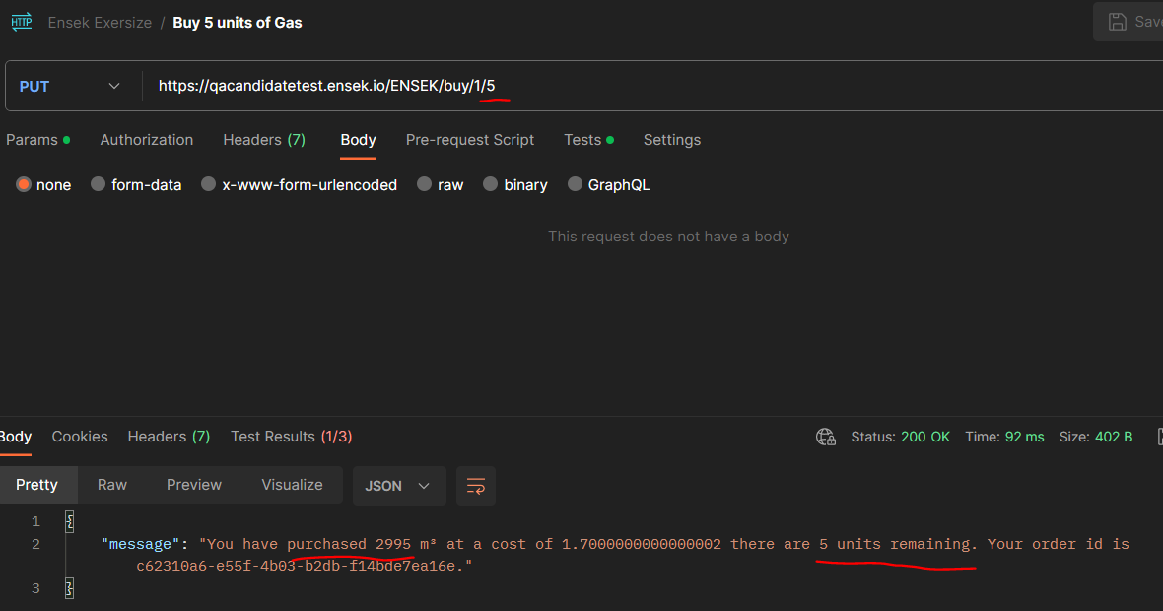Expected value: "You have purchased 5 m³ at a cost of 1.7000000000000002 there are 2995 units remaining. Your order id is c62310a6-e55f-4b03-b2db-f14bde7ea16e."

Defect 2:

Id field for oil and electic purchases does not confirm to the same format as a gas purchase, or any other pre-existing record.

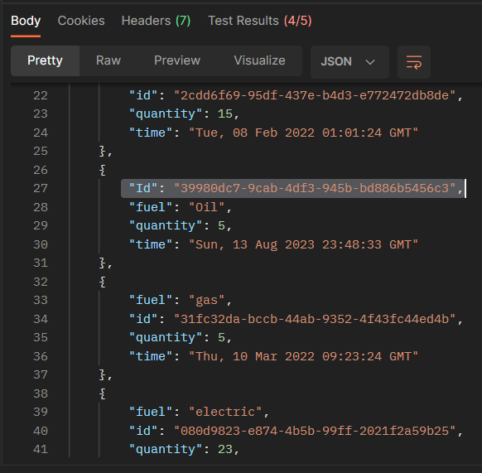

Expected result: I expected the Id to be lower case, as with all other records

Defect 3:

Lack of authentication on the get orders or purchase endpoints.

It appears only the reset endpoint requires authentication.

This is an assumption but all endpoints, other than login, should require authentication.

------------- ran out of time ------------